**Avalara Avatax Plugin**

In this document we are briefing about the functionality of Avalara Avatax plugin.

This plugin will calculate the product tax based upon the vendor’s location. Basically, plugin will interact with woocommerce and third party plugin (Doken). The plugin’s functionality will works as per settings defined in “Custom Avatax” page menu under Admin panel.

**Configuration**

This plugin need Avalara account’s “Account number” and “License key” to work. The “Account number and License key” provided by client will be saved into plugin’s setting as shown below in screenshot 3.png. Plugin will fetch all the vendor type users and create their company with the help of “/api/v2/companies” API with same Account number and license key.

*For ex: Let’s suppose we have 10 vendors in system then plugin will get all those 10 vendors from the database and create 10 companies for each vendor accordingly with same account number.*

Here are few screenshots attached in this doc that will clear settings and flow.

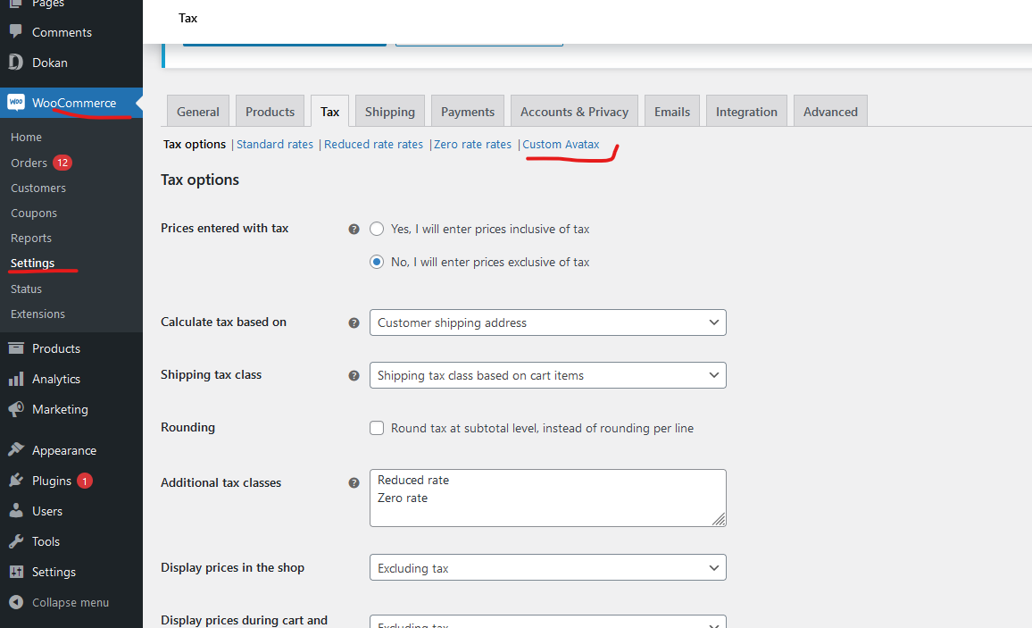

You can find plugin setting in Admin Panel by following steps.

Click on “settings” under woocommerce tab in LSB.

Click on Tax tab as highlighted in above screenshot and then click on “Custom Avatax”.

In “Custom Avatax” page you will see plugin settings that are described as below.

**Tax Calculation**

**Enable/Disable** : If this checkbox is checked then plugin will get all vendor from system and it will create company for each vendor(IF not already created). After creating company, plugin will hit transaction API(“/api/v2/transactions/create”) . This API will calculate the tax based upon vendor’s location and update tax rate for all products corresponding to each vendor’s into database.

**Record Calculations**

It will hit Transaction create API when order status will be completed.

**Commit Transactions**

It will hit transaction commit API after “Recorded Calculation”.

**Supported Locations**

List of supported countries.

**Company Code**

Company code set in Avalara Account will be display here.

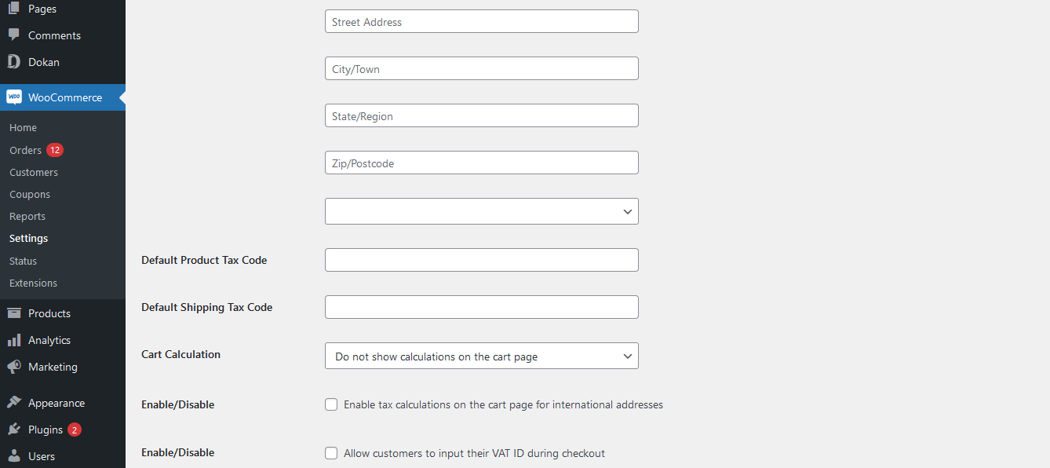

**Origin Address**

Here we’ll show the address saved in Avalara account.

**Default Product Tax Code**

If any product doesn’t have tax code, then this tax code will be applied in API’s.

**Default Shipping Tax Code**

If any product doesn’t have shipping tax code, then this tax code will be applied in API’s.

**Cart Calculation**

Please let us know the use of this feature.

**Allow customers to input their VAT ID during checkout**

It will save customer’s VAT ID into database if this option is checked in admin panel.

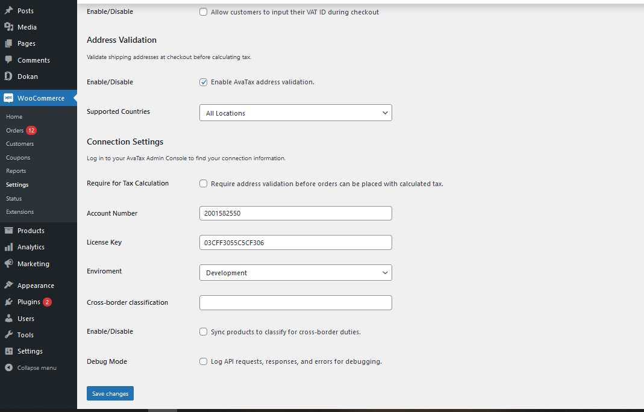

## Address Validation

## Enable AvaTax address validation.

It will enable/disable address validation on checkout page for customers.

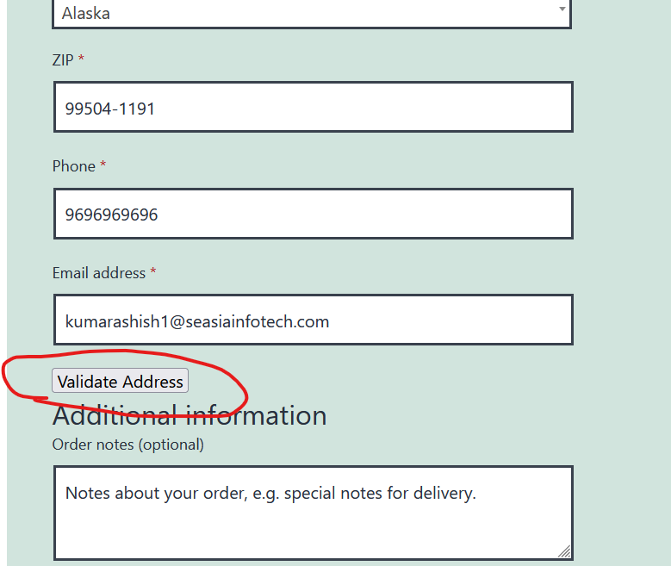

## Supported Countries

List of all countries.

## Connection Settings

**Require for Tax Calculation**

It will required tax validation before order can be placed with calculated tax.

**Account Number**

Avalara Account number provided by client for plugin configuration.

**License Key**

Avalara License Key provided by client for plugin configuration.

**Enviroment**

Weather its Production configuration or development.

**Log API requests, responses, and errors for debug**

It will enable log system for development.